# LONGINES SPIRIT ZULU TIME 1925

**What time is it there?**

Commemorating over a century of expertise in measuring time across multiple time zones, Longines is proud to release the Longines Spirit Zulu Time 1925, marking the 100th anniversary of the Swiss brand’s first dual time zone wristwatch from 1925. For the launch, Longines Ambassador of Elegance, Henry Cavill, embodies the spirit of global connection and travelling across time zones in a new campaign that poses the simple yet profound question: “What time is it there?”

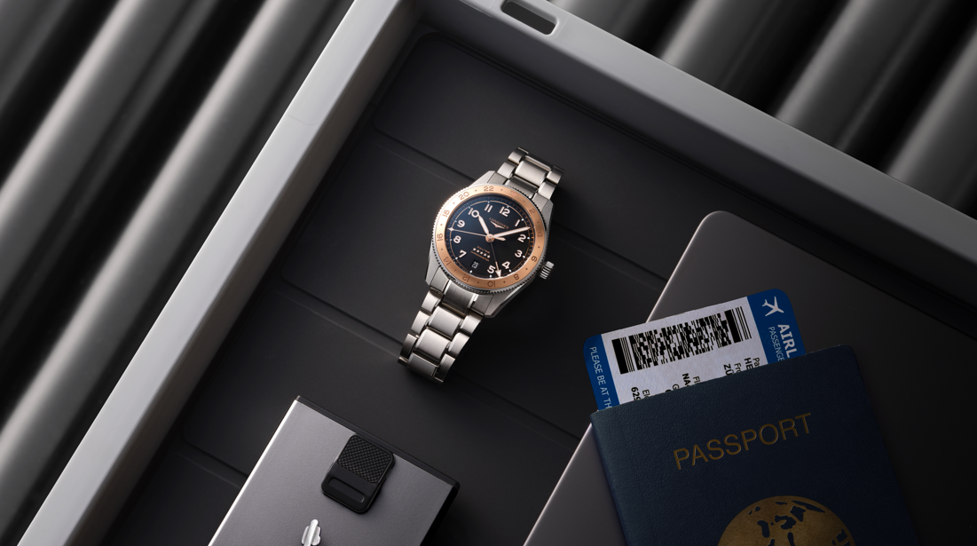

Since the late 19th century, Longines has offered precise solutions for travellers navigating multiple time zones. This heritage continued with the famous “Turkish Watches”, pocket watches with dual time zones, ordered by the Ottoman Empire in 1908 which allowed for the simultaneous reading of Turkish and Western time. In 1925, Longines introduced the first ever dual-time zone wristwatch, the “Zulu Time”. The dial featured the colourful maritime flag representing the letter "Z", which signifies the time at the zero meridian in Greenwich, London, now known as Universal Time (UTC +0). In professional aviation it is simply called "Zulu Time". This 4-digit time format eliminates the confusion of AM and PM indicators. Zulu Time continues to be used by pilots and navigators to ensure clear communication during radio contact.

In 2022, Longines reinterpreted this historic timepiece by launching the Longines Spirit Zulu Time collection, boasting state-of-the-art watchmaking technology. The collection quickly established itself as an essential companion for modern globetrotters, with its precise GMT functionality and distinctive aesthetic.

**From 1925 to 2025**

Now in 2025, to celebrate the centennial of this groundbreaking timepiece, the brand proudly unveils the Longines Spirit Zulu Time 1925. This commemorative edition features a 39-mm stainless steel case with a bidirectional rotating bezel adorned with exquisite 18K rose-gold cap, circular-brushed insert — a first for the collection — and 24-hour graduations, enabling the wearer to track a third time zone. The meticulously engraved numbers and indexes add both depth and refinement to the design, while the choice of rose gold, which contains copper, pays homage to the copper strip marking the Prime (or “zero”) Meridian that is embedded in the ground at the Royal Observatory at Greenwich, erected 350 years ago.

The matt black dial creates a striking contrast with the rose-gold-coloured hands and indexes, providing exceptional legibility. Both the hands and hour markers are treated with Super-LumiNova® for optimal readability in all lighting conditions. The dial is further distinguished by five stars elegantly positioned above the 6 o’clock marker, where there is also a discreet date window and the years “1925 – 2025” elegantly engraved in a subtle tone-on-tone finish, marking the centennial celebration. In two more firsts for the Longines Spirit Zulu Time collection, a transparent case back reveals a rose-gold-coloured PVD rotor featuring a special engraving of a planisphere with the Prime Meridian running through its centre.

**Precision across time zones**

A true (or “traveller”) GMT watch, it is powered by the exclusive Longines calibre L844.4, a self-winding mechanical movement with a silicon balance spring and innovative components that make it up to 10 times more resistant to magnetic fields than the ISO 764 standard requires. This high-precision movement provides a power reserve of up to 72 hours and is chronometer-certified by the Official Swiss Chronometer Testing Institute (COSC).

The Longines Spirit Zulu Time 1925 comes with both a stainless steel bracelet featuring a double-folding safety clasp and a black NATO strap with a pin buckle. The watch is presented in a special-edition box that reflects the significance of this anniversary timepiece.

**The collection evolves**

In addition to this commemorative model, Longines is also expanding the Spirit Zulu Time collection with new stainless steel designs in 39 mm and 42 mm diameters. Available later this year, these timepieces feature a bidirectional rotating bezel and ceramic insert with a 24-hour scale divided into two shades, matt black and intense polished black, elegantly indicating day and night hours. Like the anniversary edition, these models adopt the same sophisticated black dial and rose gold accents, creating a harmonious aesthetic across the collection while offering additional size and material options for different preferences.

**Celebrating heritage and innovation**

The Longines Spirit Zulu Time 1925 honours not only the brand’s innovative past but also its continued commitment to precision, elegance and the pioneering spirit that has characterised Longines throughout its history, while connecting a legacy of horological innovation with the contemporary needs of global travellers. This anniversary edition stands as a testament to how the art of fine watchmaking can bridge both time and distance, remaining as relevant in today’s interconnected world as it was a century ago.

### Connecting across time zones with Henry Cavill

The new Longines Spirit Zulu Time 1925 campaign explores the timeless question that connects people across distances: “What time is it there?” Starring Longines Ambassador of Elegance and internationally acclaimed actor, Henry Cavill, the campaign depicts the emotional connection between two people navigating international skyways yet remaining inextricably linked across time. As Cavill moves through global airports and destinations, his Longines timepiece serves as a private language that bridges continents and time zones. The campaign visualises how a Spirit Zulu Time watch becomes more than a precision instrument to form a symbolic connection between loved ones, helping them synchronise their lives despite physical separation. For the modern traveller, time becomes a shared language with the most important person in their life, balancing global careers and personal moments across time zones, with a glance at their wrist bringing them closer together.

***“For me, the Spirit Zulu Time represents not only precision time keeping, but also connection. In today's lifestyle, our loved ones and colleagues can often be a world away. However, the Spirit Zulu Time gives me, at a glance, that immediate connection with them, and it does so with the elegance that Longines excels at.”***

Henry Cavill

### Longines Spirit Zulu Time: evolving for today’s global explorers

The Longines Spirit Zulu Time collection, first introduced in 2022, exemplifies the brand’s century-old expertise in timepieces designed for world travellers. Drawing its inspiration and name from the first ever dual time zone wristwatch created in 1925, featuring the iconic maritime signal flag for the letter “Z”, which is used in conjunction with number flags to indicate time, the collection began with distinctive 42 mm models that established the line’s elegant sport design. In 2023, Longines expanded the collection to include 39 mm versions that offered the same exceptional performance in a more compact case, with options including a model adorned with gold to enhance their allure.

The evolution continued in 2024 with the introduction of a titanium design of exceptional lightness and durability, ideal for the most adventurous travellers. Now, in 2025, alongside the centennial celebration models, Longines introduces new versions featuring blue ceramic bezels that create a striking contrast with the anthracite dial. This elegant colour interplay enhances both aesthetics and readability, particularly when tracking a second time zone. All Longines Spirit Zulu Time watches are powered by exclusive Longines GMT calibres featuring silicon balance-springs and COSC chronometer certification, ensuring superior accuracy across different time zones while remaining true to the dual pursuits of innovation and tradition that have always defined the Longines brand.

### Pioneering time zones: a heritage of innovation across meridians

### The standardisation of time zones in the late 19th century revolutionised global travel and communication. Before this milestone development, each locality kept its own local time based on the sun’s position, creating practical challenges as railway networks expanded and international travel increased. The establishment of Greenwich as the Prime Meridian in 1884 and the subsequent division of the world into 24 time zones created a universal system that allowed people to synchronise activities across vast distances. The term “Zulu” has its origins in the NATO phonetic alphabet, where it designates the letter “Z” – that is, zero, or GMT+0 for Greenwich Mean Time. The designation became particularly important in aviation and maritime operations, where precise time coordination across different regions proved essential for safety and navigation.

### Longines established itself as a preeminent expert in multiple time zone watches by pioneering solutions for this new global reality. The brand created history with its famous Turkish Watches in 1908 – the first dual-time zone pocket watches – and secured this innovation with a patent in 1911. In 1925, Longines advanced horological history again by introducing the world’s first dual time zone wristwatch, the Zulu Time, which displayed both local time and Greenwich Mean Time (UTC+0) for the Royal Canadian Navy. The watch featured the signal flag for the letter “Z” – a symbol used by both sailors and aviators in international time communications.

### By the early 1930s, Longines had developed one of the first true GMT cockpit clocks, which became indispensable tools for aviation pioneers like Hugh Herndon and Clyde Pangborn during their historic non-stop Pacific crossing in 1931. This unmatched legacy of precision across multiple time zones continues today with the Longines Spirit Zulu Time collection, offering contemporary global travellers the same reliability that has made Longines the definitive authority in international navigation timepieces for over a century.

### TIMELINE:

### Over 100 years of expertise in developing timepieces to indicate multiple time zones

|  |  |  |
| --- | --- | --- |
|  | *1908* | **The Turkish Watches**  This pocket watch was the first to display two time zones on a single dial, with dual minute and hour hands to convert Turkish time to Western European time. Patented in 1911, the 49-mm pocket watch displays 5 hands and is equipped with the Longines hand-wound calibre 18.69N. |
|  | *1925* | **Longines Zulu Time**  The first wristwatch to display both the local time and a second time zone on the same dial. The small nautical flag below 12 o’clock stands for the letter “Z”, referred to as Zulu in the phonetic alphabet. The Zulu time format is used in professional and military aviation and corresponds to UTC +0. The square 34 x 24 mm case is made of 18-carat white gold and houses the Longines hand-wound calibre 10.68N. |
|  | *1930* | **Longines Weems**  A pilot’s wristwatch with two sets of independently adjustable hands. Dual minute and hour hands indicate a second time zone. The 47.5-mm silver case houses the 18.69N calibre. |
|  | *1931* | **Longines Cockpit Clock**  Furnished to pioneering aviators Clyde Pangborn and Hugh Herndon, this timepiece features dual minute and hour hands and a 24-hour pilot’s dial. The large pusher stops the movement and synchronises it with a radio time signal. The 90.5-mm cockpit watch is equipped with the Longines hand-wound calibre 18.69N. |
|  | *1935* | **Longines pilot’s watch with inner rotating bezel, ref. 3775**  A dual mobile dial pilot’s watch with a rotating bezel protected by glass. Longines was the first brand to use this type of bezel. This technique was later used in the Longines Legend Diver. The 32.5 mm watch is equipped with the Longines hand-wound calibre 12.68Z. |
|  | *1937* | **Longines Cockpit Clock**  Cockpit instrument with rotating bezel and luminescent indicator showing two time zones. The 82.5 mm watch is equipped with an 18.69N calibre. |
|  | *2022* | **Longines Spirit Zulu Time, ref. L3.812.4.63.2**  Part of the Longines Spirit family, the collection takes its inspiration and name from the world’s first dual time zone wristwatch. 42 mm case; water-resistance up to 10 bar (100 m). Bidirectional rotating bezel with ceramic insert. Automatic winding, exclusive Longines calibre L844.4 with GMT function. Officially chronometer certified by the COSC. |
|  | *2025* | **Longines Spirit Zulu Time 1925, ref. L3.803.5.53.6**  A unique model to mark the 100th anniversary of Longines’ first dual time zone wristwatch from 1925. 39 mm case; water resistance up to 10 bar (100 m). Bidirectional rotating bezel with rose gold cap insert. Automatic winding, exclusive Longines calibre L844.4 with GMT function. Officially chronometer-certified by the COSC. |

***About our movements***

*Backed by centuries of watchmaking expertise, Longines has pioneered many technical advances and still displays an unfailing will to innovate. Its constant pursuit of excellence has led Longines to equip all its automatic timepieces with cutting-edge movements whose features include a silicon balance-spring. Silicon is not only lightweight and corrosion-resistant, but also impervious to normal temperature fluctuations and magnetic fields. Its unique properties boost the watch’s precision and longevity and allow Longines to guarantee these models for 5 years.*

#### About Longines

Longines has been established in Saint-Imier, Switzerland, since 1832. The watchmaking house boasts expertise forged in tradition, elegance and high performance. With its long-standing experience as official timekeeper of world sports championships and partner of international sports federations, the Swiss watch brand has forged strong and lasting links with the sporting world over the years. Renowned for the elegance of its models, Longines is a member of Swatch Group Ltd, the world’s leading manufacturer of timepieces. The brand with the winged hourglass as its emblem has outlets in over 150 countries.